|  |  |
| --- | --- |
|  | **FPT ACADEMY INTERNATIONAL**  **FPT – APTECH COMPUTER EDUCATION** |

**Centre Name: ACE-HCMC-2-FPT.**

**Address: 590 Cach Mang Thang 8, District 3, Ho Chi Minh City, Viet Nam.**

**HKTT Store**

Installation Guide

|  |  |  |
| --- | --- | --- |
| **Supervisor:** | MR. NGO PHUOC NGUYEN | |
| **Semester:** | 4 | |
| **Batch No:** | T1.1807.M0 | |
| **Group No:** | 1 | |
| **Order:** | **Full name** | **Roll No.** |
| 1. | LE NGOC DANG KHOA | Student1111538 |
| 2. | PHAM HUYNH | Student1107484 |
| 3. | HA MINH TAN | Student1113368 |
| 4. | HOANH THANH TAI | Student1120083 |

June 2020**I. Software and Hardware Requirement**

1. **Admin, server requirement**

* Hardware

|  |  |
| --- | --- |
| **Component** | **Requirement** |
| **CPU** | Processor type:  Pentium IV-compatible processor or faster  Processor speed:  Recommended: 2.0 GHz or faster |
| **OS** | Microsoft Windows Server 2012 with IIS |
| **Memory (RAM)** | RAM:  Minimum: 2 GB  Recommended: 4 GB or more |
| **Hard Drive** | Free space:  Minimum: 10 MB  Recommended: 50 GB or more  Maximum: Operating system maximum |

* Software

|  |  |
| --- | --- |
| Component | Requirement |
| Microsoft .NET Core | Version 3.1 or higher |
| IIS Manager | Version 10.0 or higher |
| RDBMS | Microsoft SQL Server 2017 |
| Netbean | Version 11.3 or higher |
| JavaEE | JavaEE 7 SDK |
| Java Development Kit | Java Development Kit (JDK) 1.7 |
| Glassfish Server | Glassfish Server 4.0 |
| Web browser | 1. or higher. |

1. **Client mobile requirement**

* Hardware
* Android phone with Android 8.0 Oreo (API 26) or later.
* Atleast 2GB of RAM.
* Internet connection required.
* Software
* Allowing app installs from Unknown Sources since we can not publish to Google play.

**II. CONFIGURATION**

* After you have downloaded our project file, please extract it. There are 4 sub-folders inside the folder:

+ **“Database” folder:** storing **query script for the database**.

+ “**Deploy” folder**: storing API publish folder and java web jar

+ **“Source code” folder:** where the souce code of admin web, API and android app is stored.

+ **“Document”** where the **eProject report, feedback, and the installation guide** in document format are stored. These file have a copy in PDF format in root.

**Please read the installation guide and then the user guide before running our application.**

**Step 1: Setup database**

**1. Open SQL Server Configuration Manager**

Start => All Programs => Microsoft SQL Server 2019 => SQL Server

Configuration Manager.

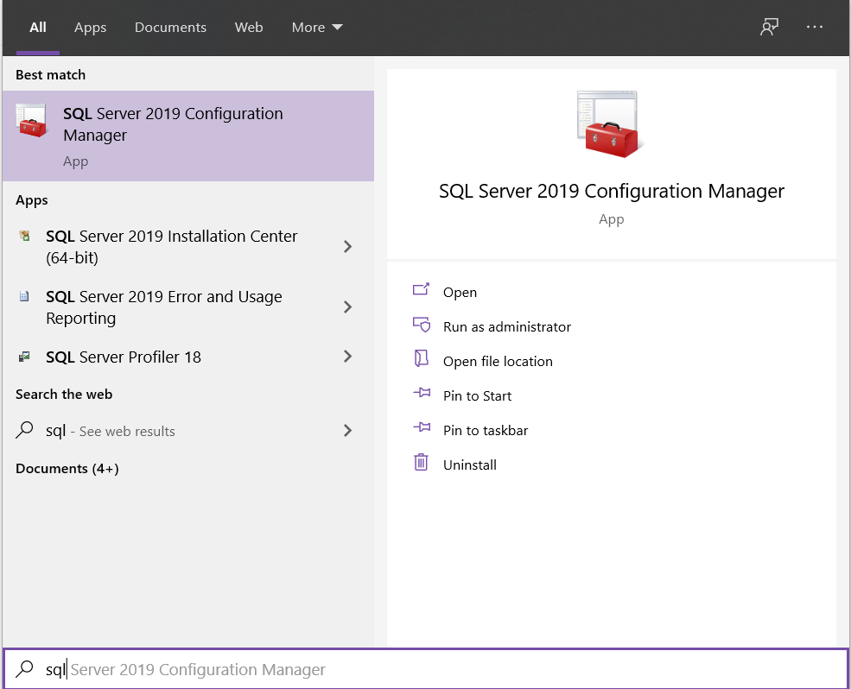

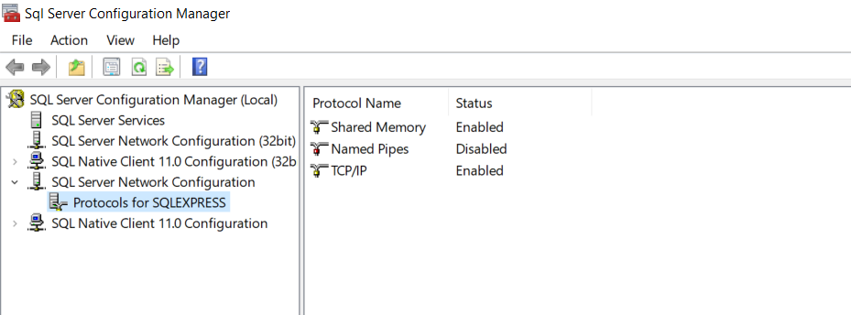

**2. Configure TCP/IP**

**Set TCP/IP**

Right click TCP/IP => Properties (in Protocols for SQLEXPRESS)

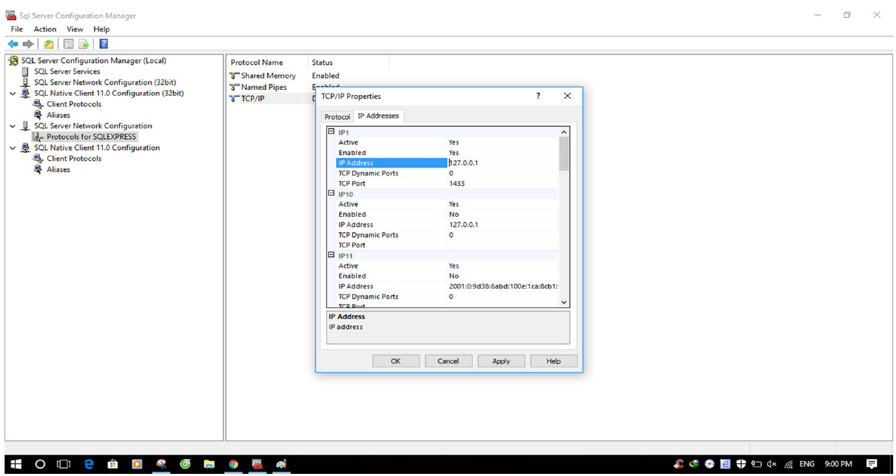

Select IP Addresses tab

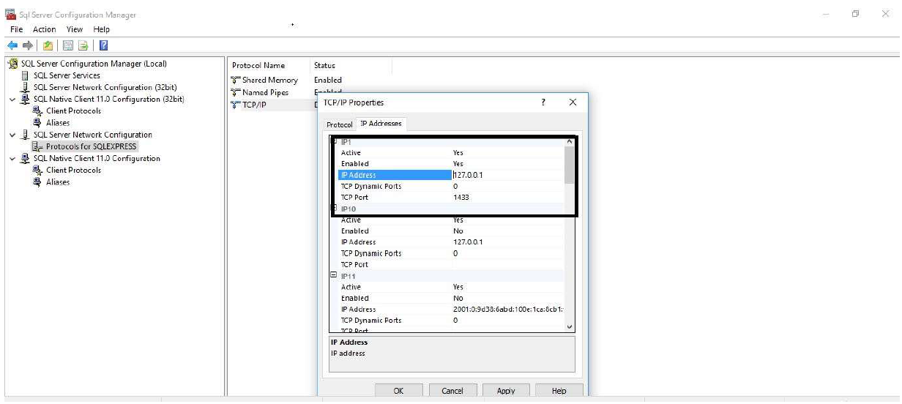

On IP1, set value for IP Address: 127.0.0.1, TCP Port: 1433

Click OK button

**3. Enable TCP/IP:**

Right Click TCP/IP => Enable

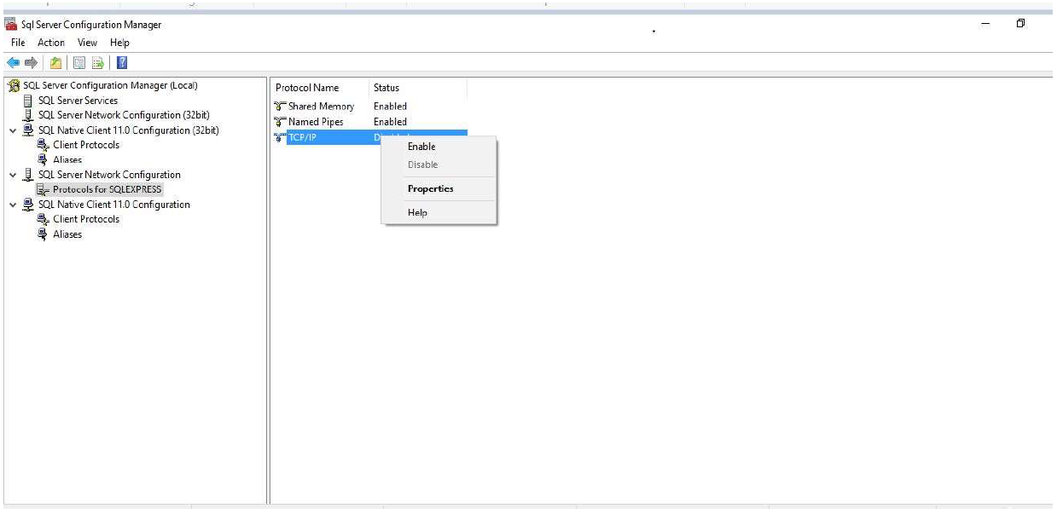

Select OK

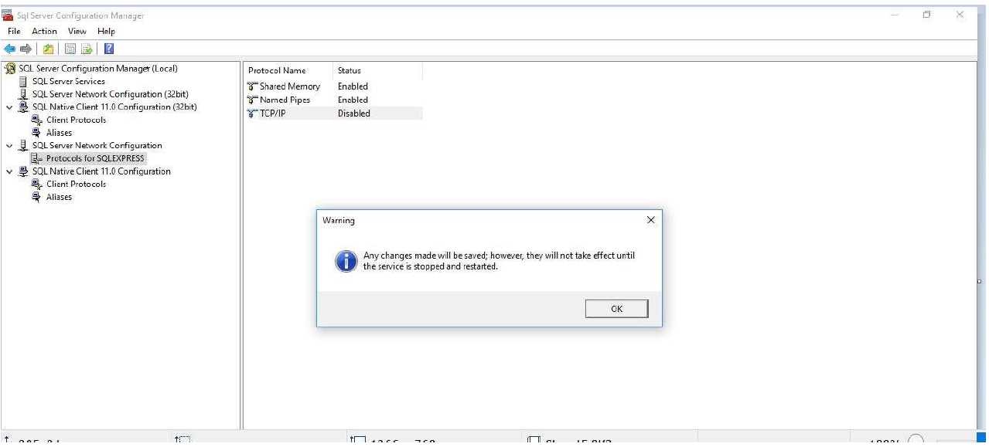

Result: TCP/IP in enabled

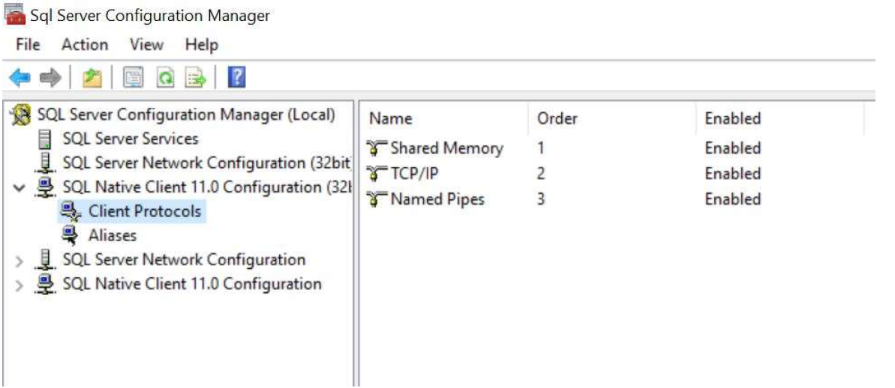

**4. Restart SQL Server 2019 to apply changes:**

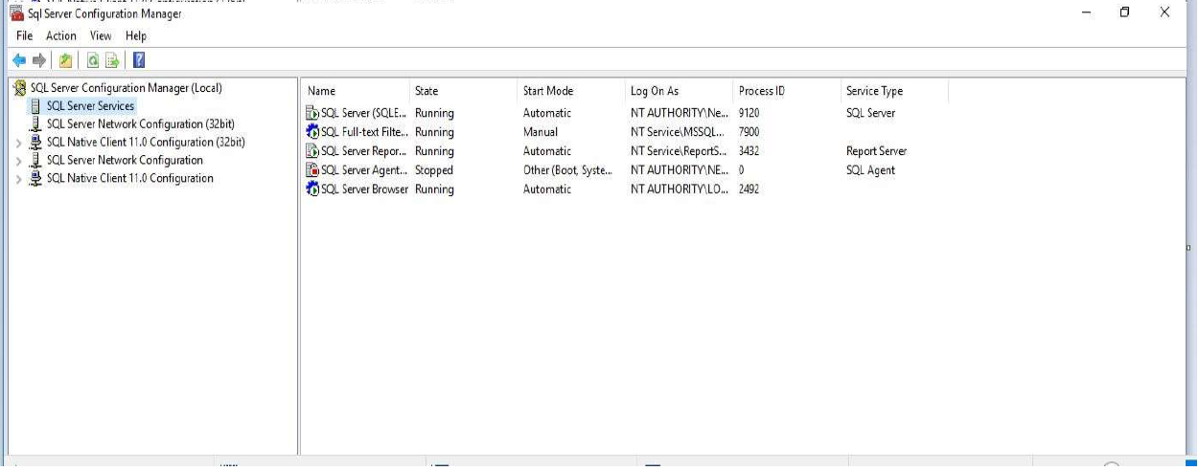

Select SQL Server Services => Right click SQL Server(SQLEXPRESS) =>

Restart

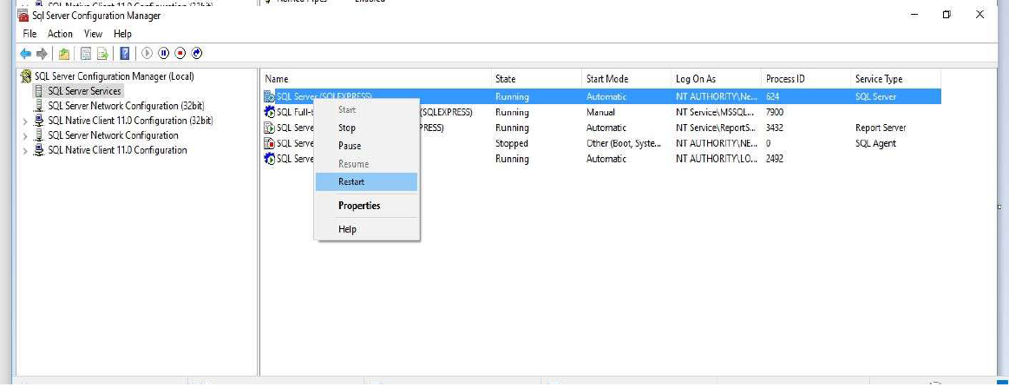

**STEP 2: Install Database**

**1. Open MS SQL Server Management Studio:**

Start => All Programs => Microsoft SQL Server 2019 => SQL Server

Management Studio

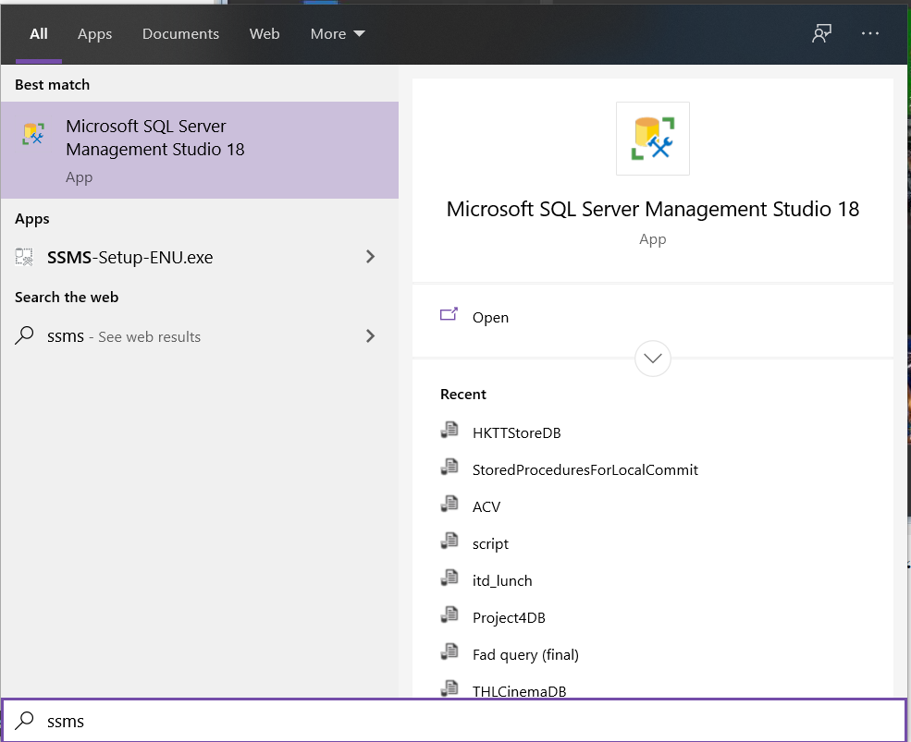



Input your login name and password => Click “Connect” button

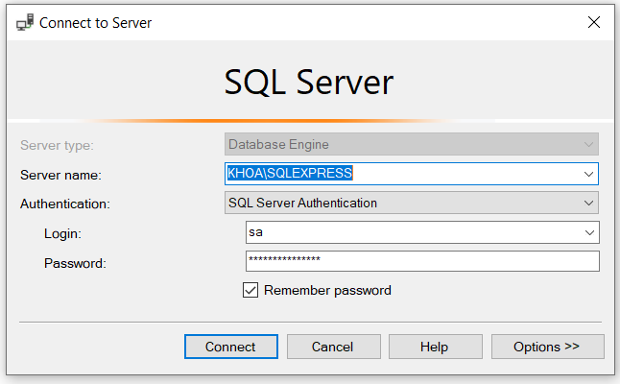

**2. Setup database:**

Open HKTTStoreDB.sql file to setup database:

In Menu choose : File => Open => Files...

Select HKTTStoreDB.sql file in “Group1_ProjectSEM4” folder =>

click Open

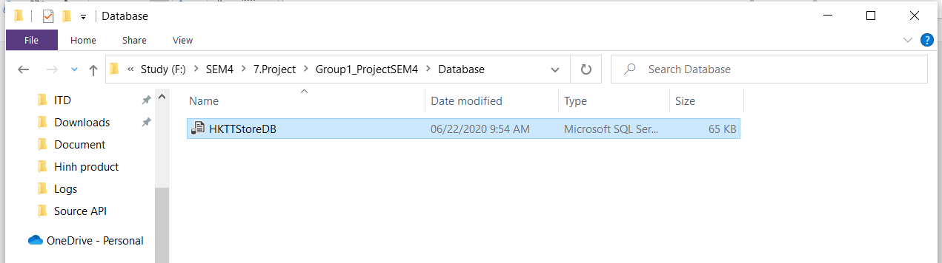

Execute HKTTStoreDB.sql file to create HKTTStoreDB database (Click “Execute” button on toolbar or Press F5 on keyboard).

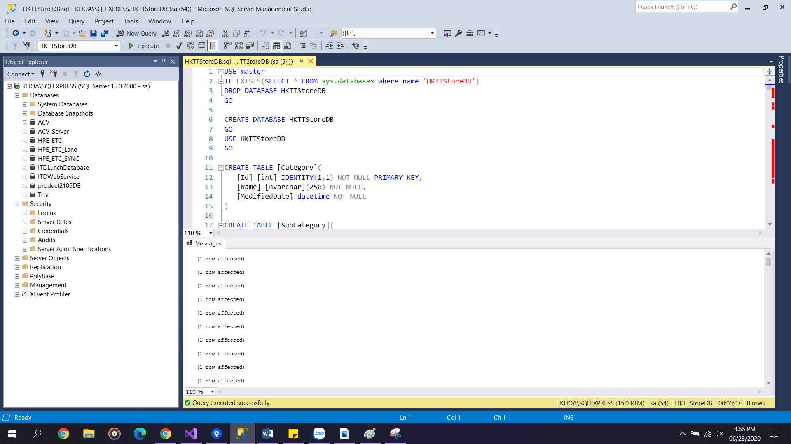

Right click Database => Refesh

Result : Appear the Project4DB database in Databases folder

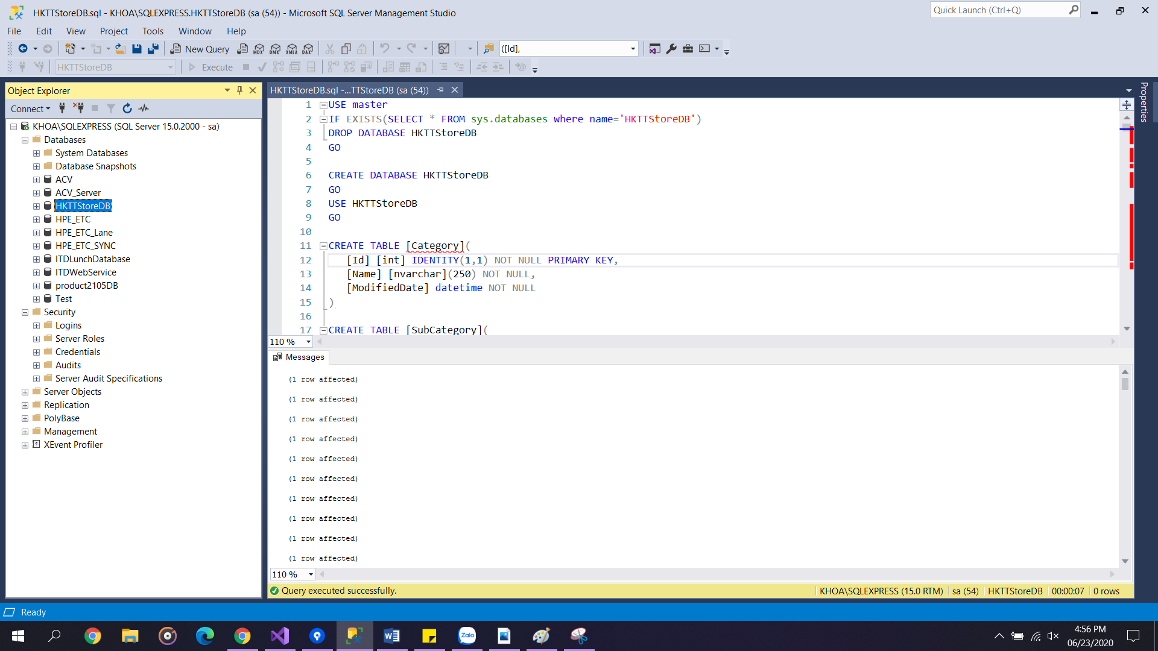

Create Database successfully

**Step 3: Publish admin web**

Find location of your glassfish 4.0 server which usually be **glassfish4** in the test computer. Navigate to bin folder in glassfish4 and open Command Prompt Windows here.

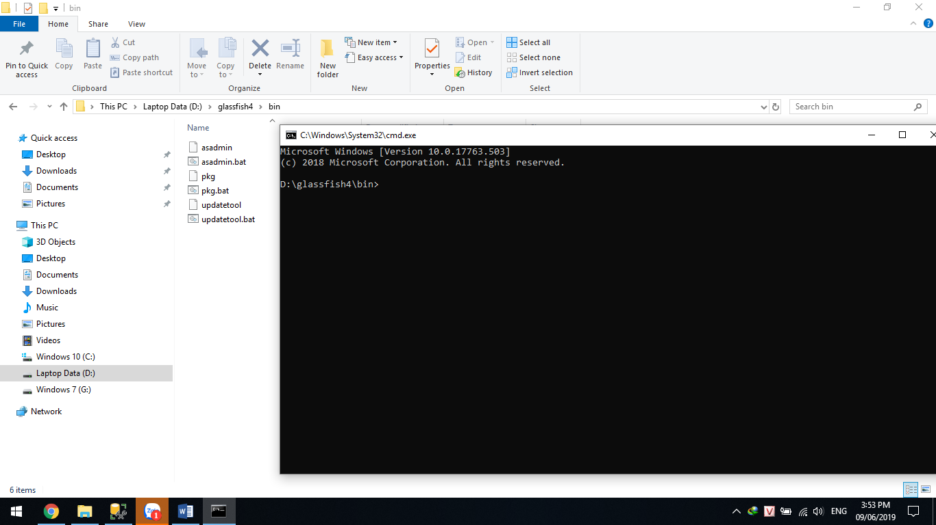

Type in Command Prompt Windows “asadmin start-domain domain1” to start domain1 on glassfish server. The result must be command executed successfully

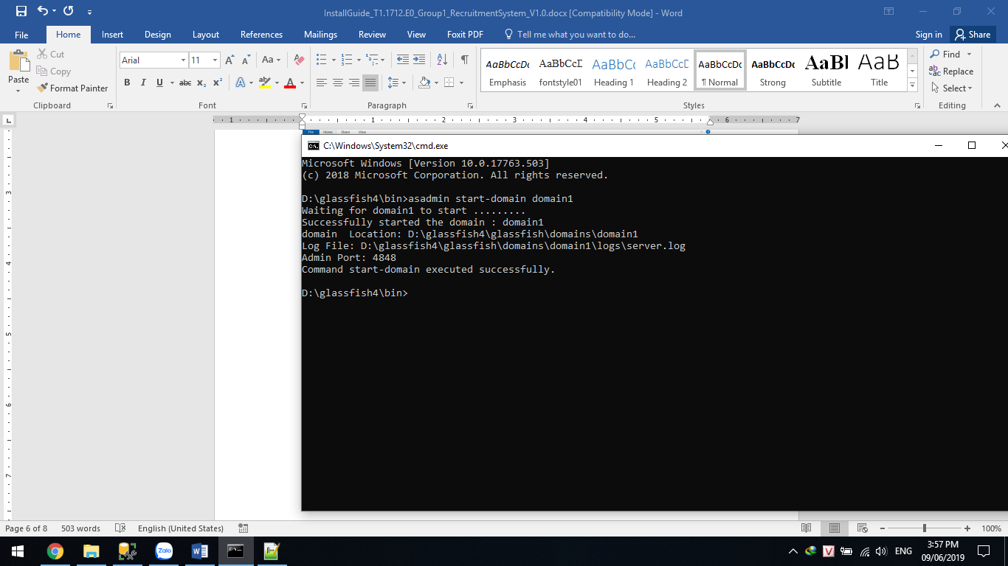

**Create jdbc connection pool**

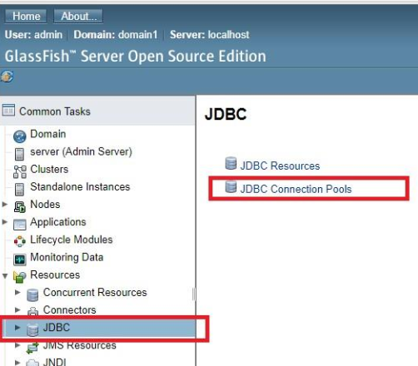

Then press the "New" button.

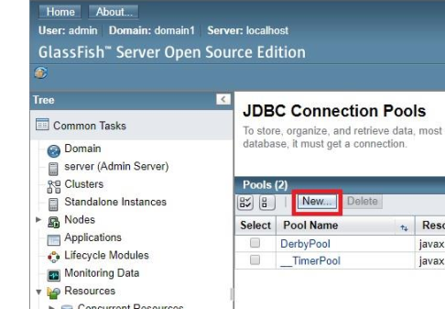

In the next screen, enter the information of the 3 fields with the following values:

+ Pool Name: HKTTStoreDB

+ Resource Type: javax.sql.DataSource

+ Database Driver Vendor: MicrosoftSqlServer

Then click the "Next" button.

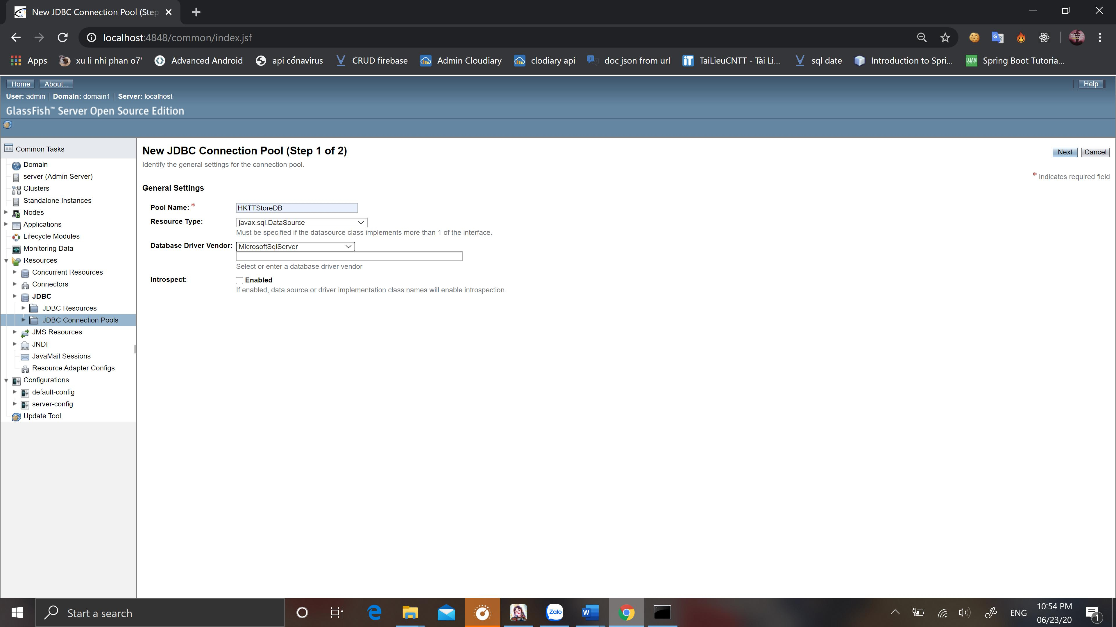

In the next screen, scroll down to see the "Additional Properties" panel. You select the fields and enter the following values:

+ User: your user to connect to SQL Server (usually "sa")

+ URL: jdbc: sqlserver: // localhost; database = HKTTStoreDB

+ Password: password to log into your SQL server

+ DatabaseName: HKTTStoreDB

+ ServerName: localhost

+ PortNumber: 1433

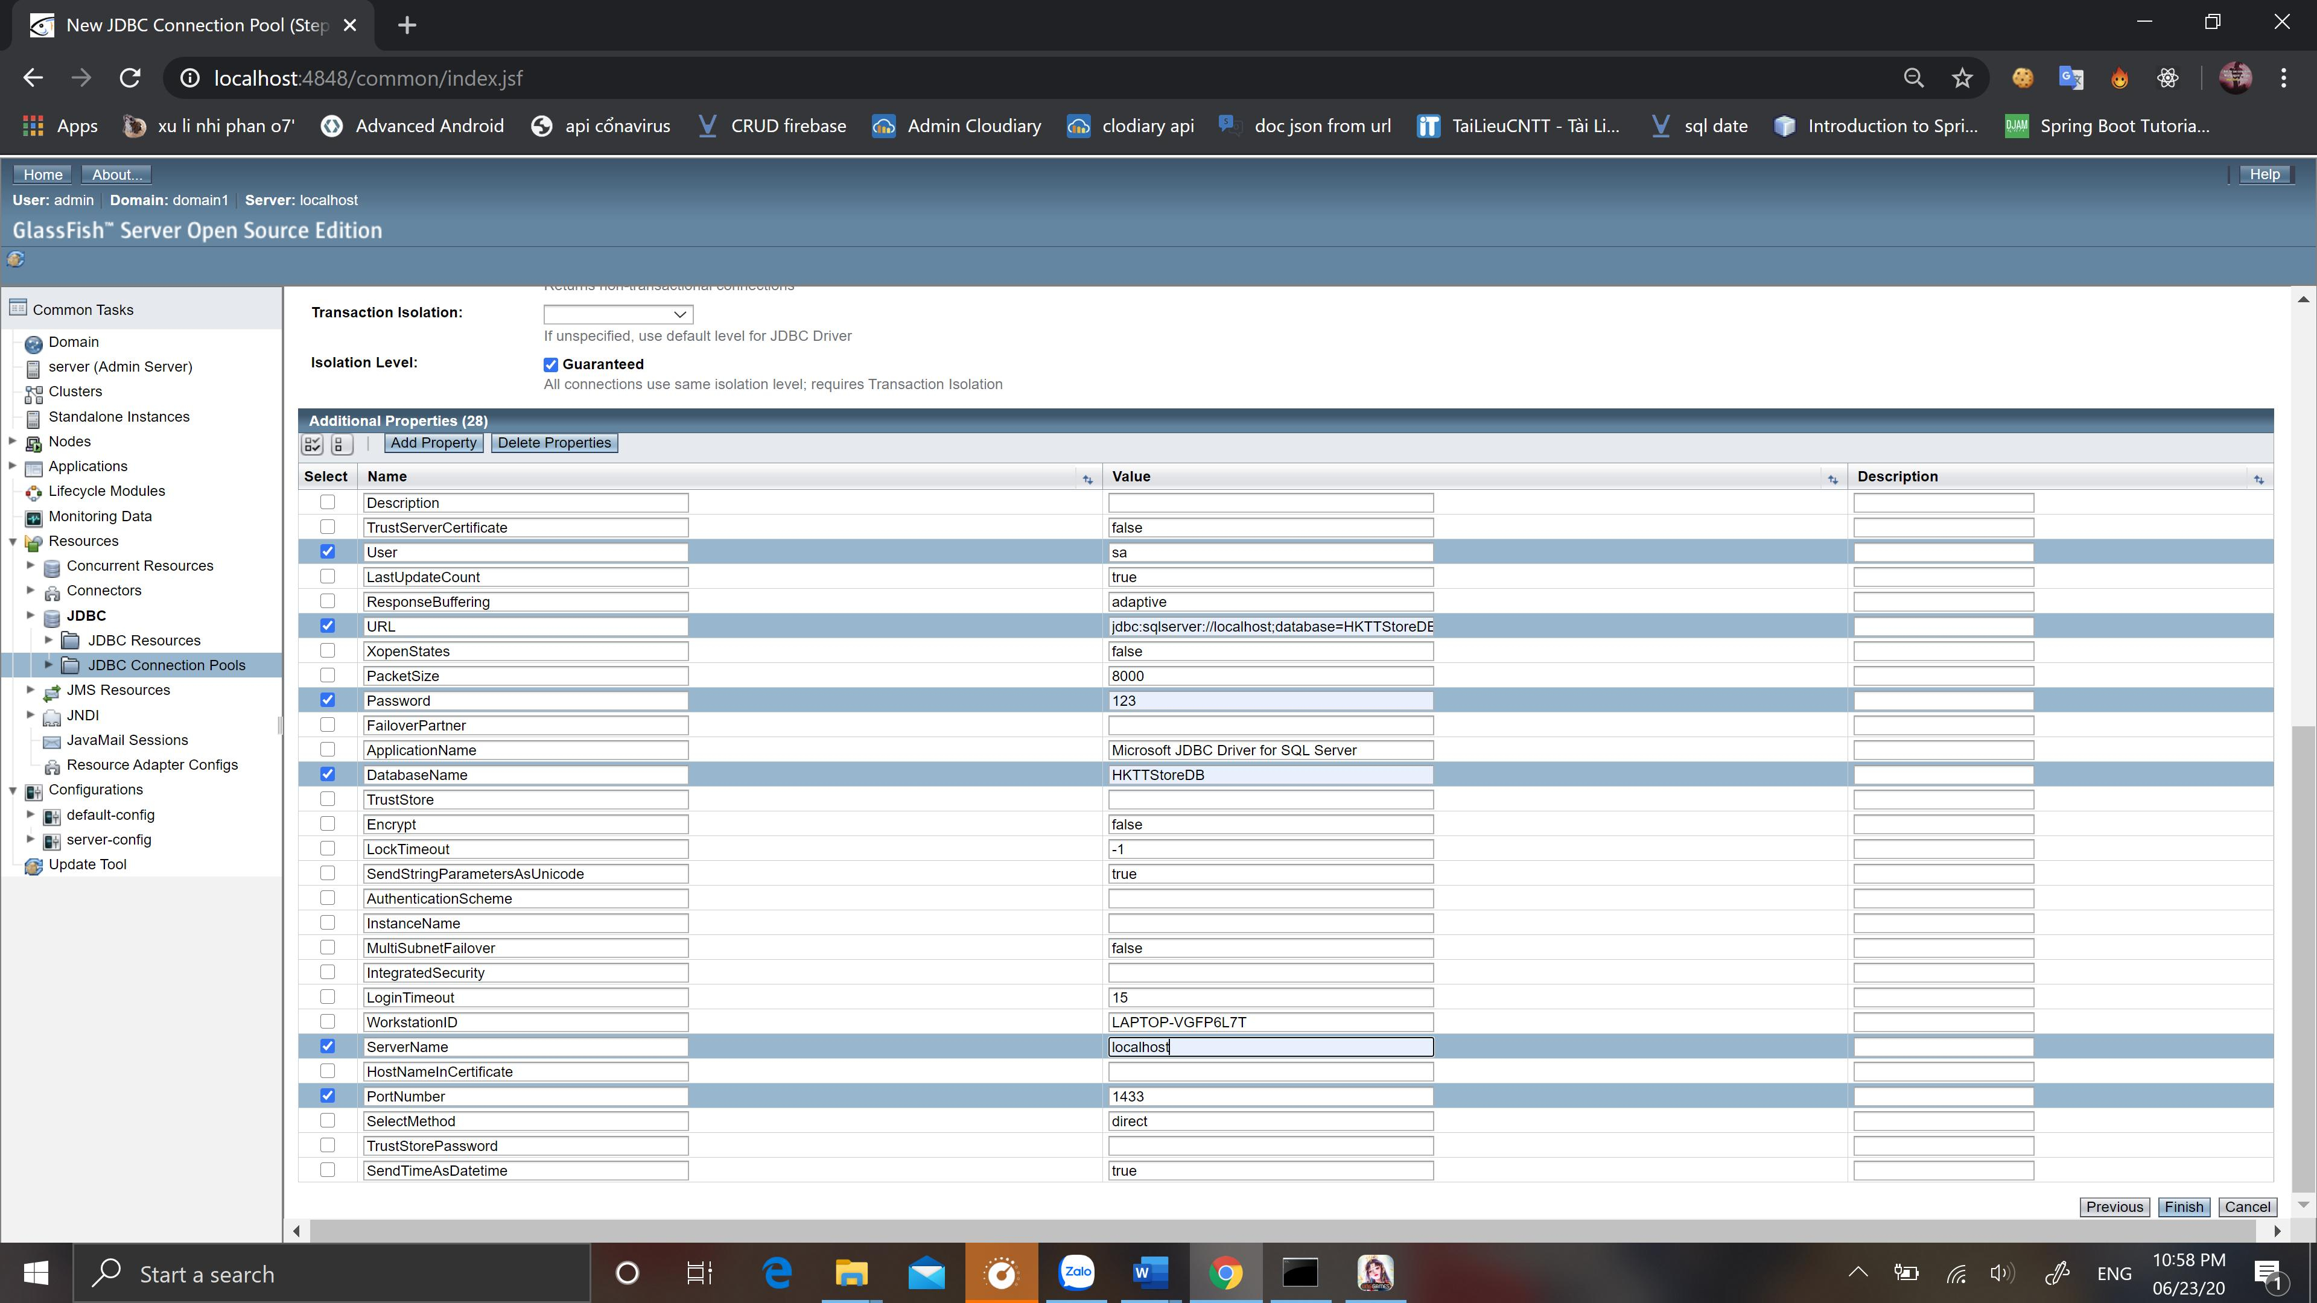

Then press the "Finish" button.

You create a new "jdbc connection pools" with the name HKTTStoreDB

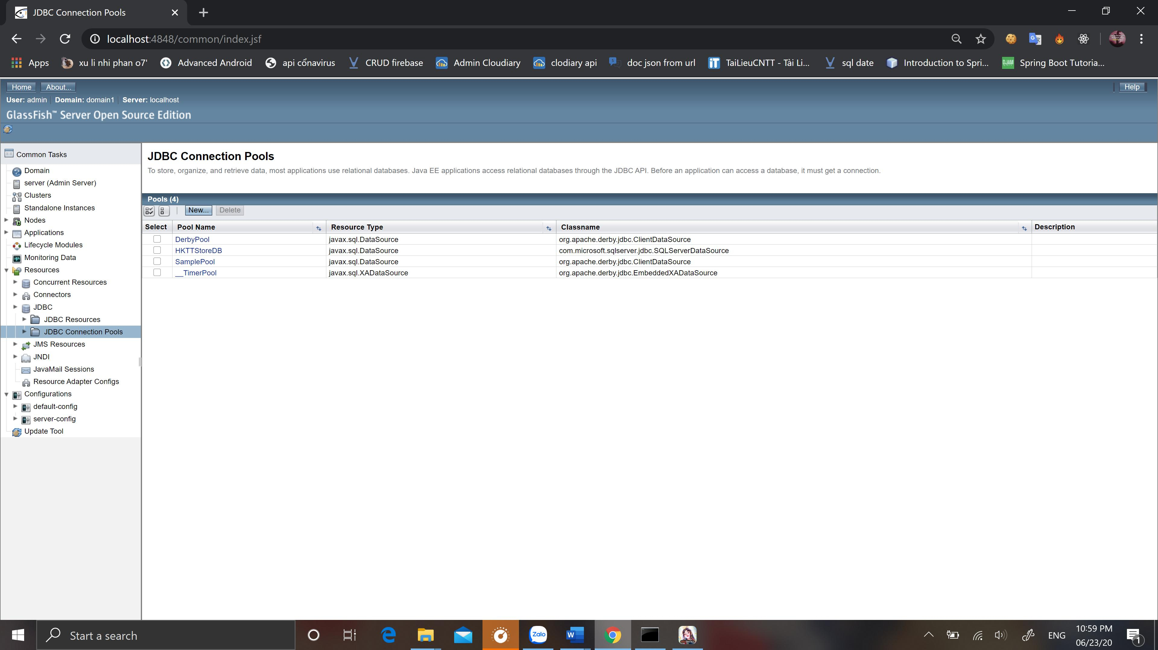

To check the connection pool, click the PoolName column named HKTTStore. In the next screen, click the Ping button and you will see the message "Ping Succeeded".

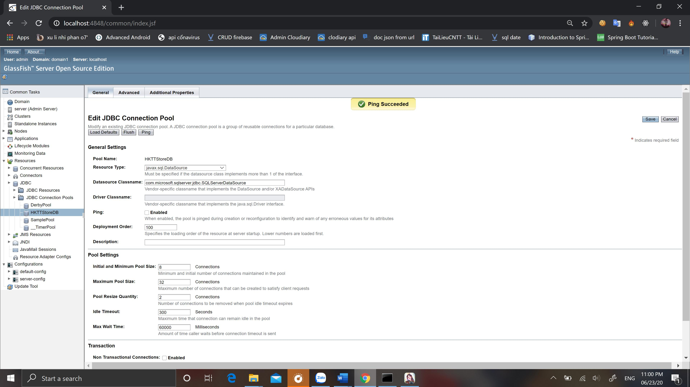

**Create jdbc resource**

Click on JDBC Resources and then click the New button as shown below:

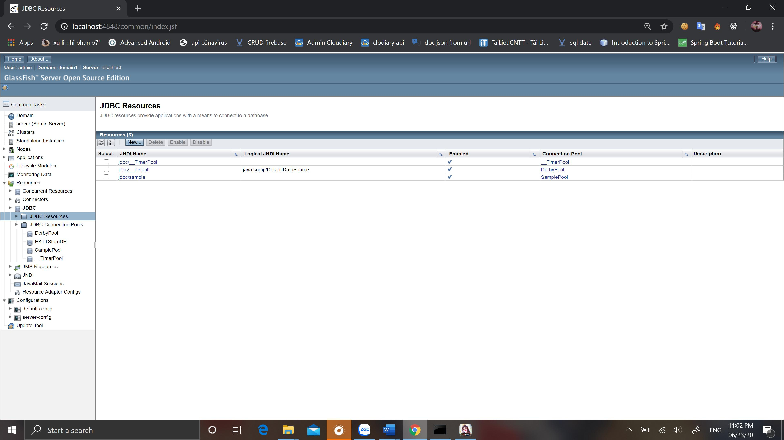

In the next screen, you enter fields with the following values:

+ JNDI Name: HKTT_JNDI

+ Pool Name: HKTTStoreDB

Then press the "OK" button.

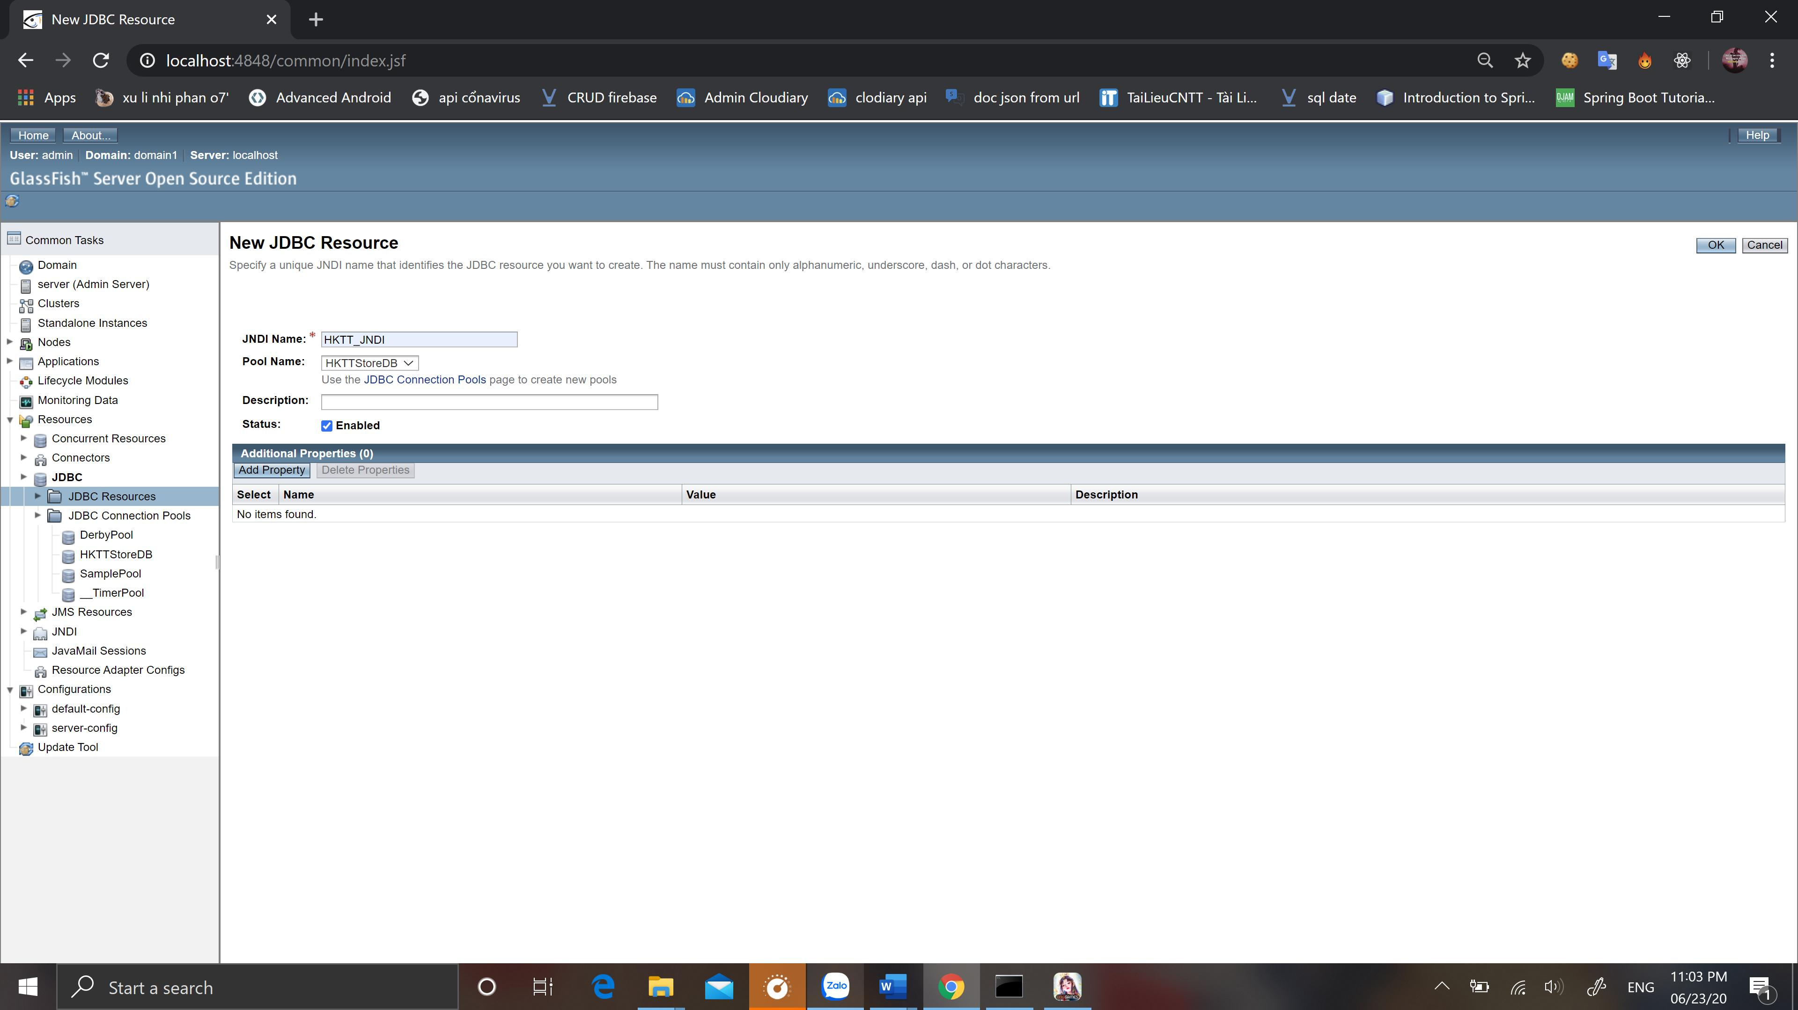

You will be redirected to the JDBC Resources screen. At this time, a resource jdbc

just created with the name HKTT_JNDI

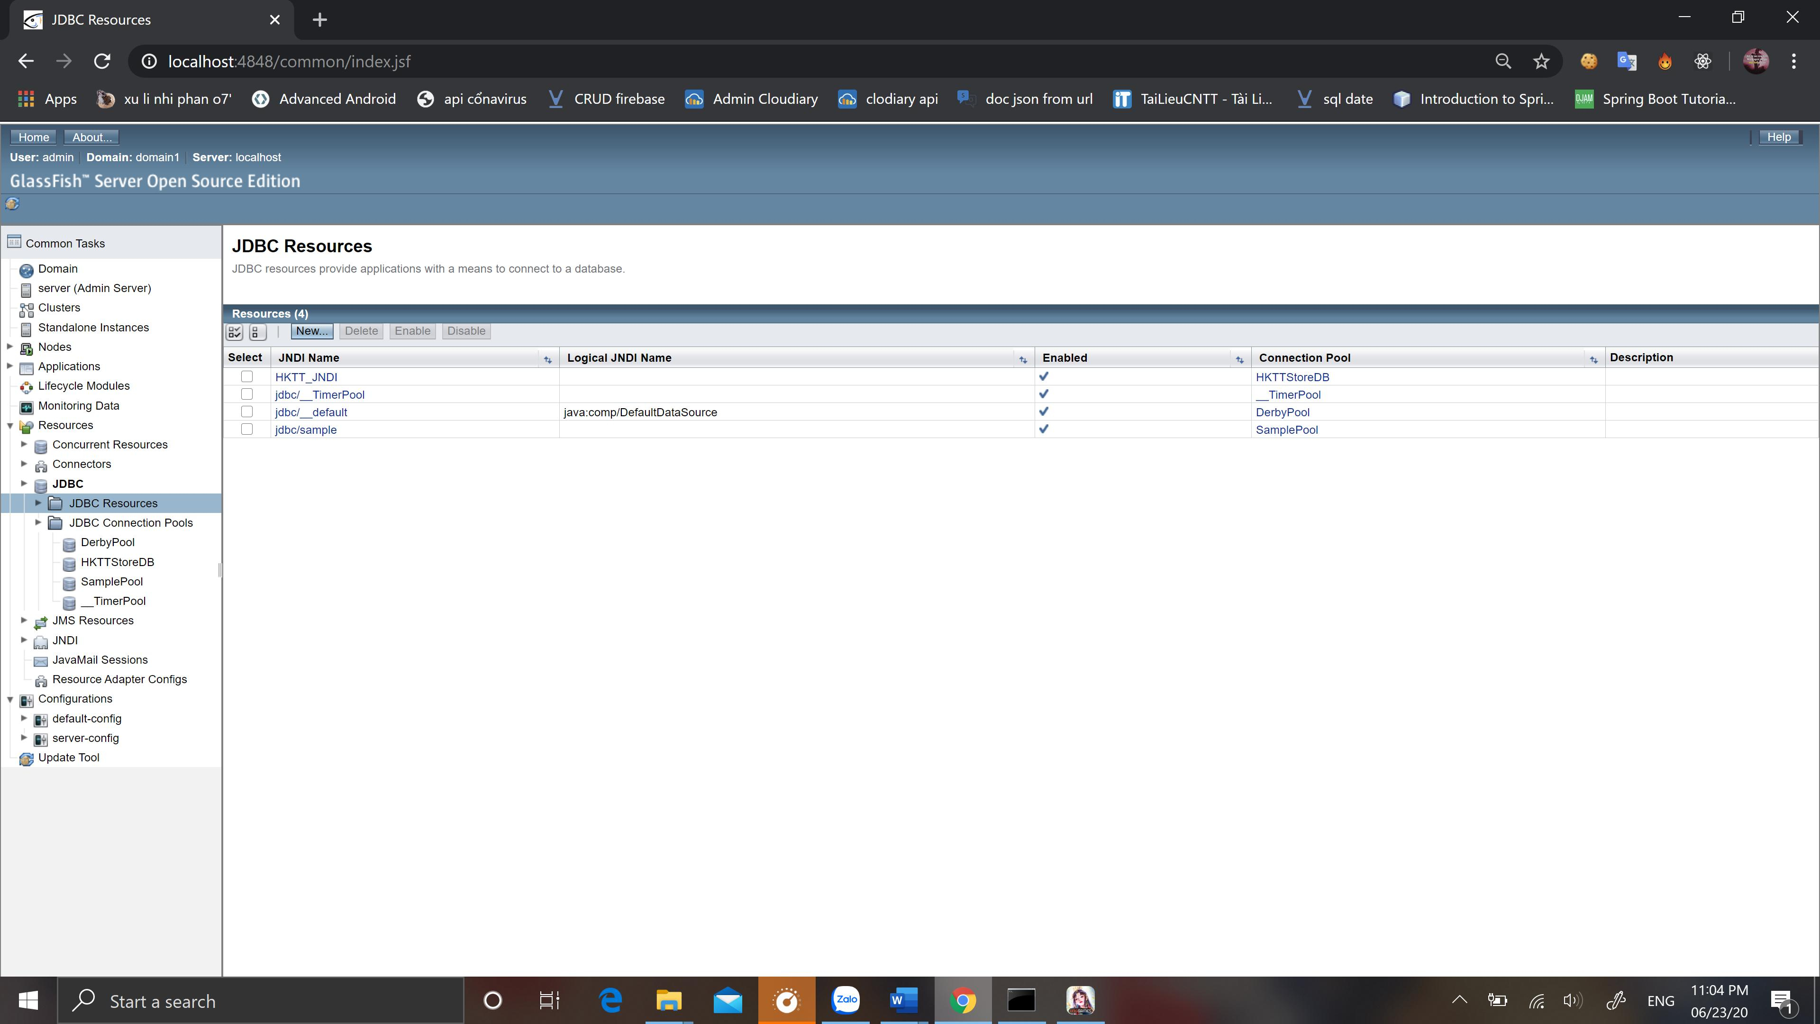

**Deploy website**

Click on Applications then click on the "Deploy" button as shown below:

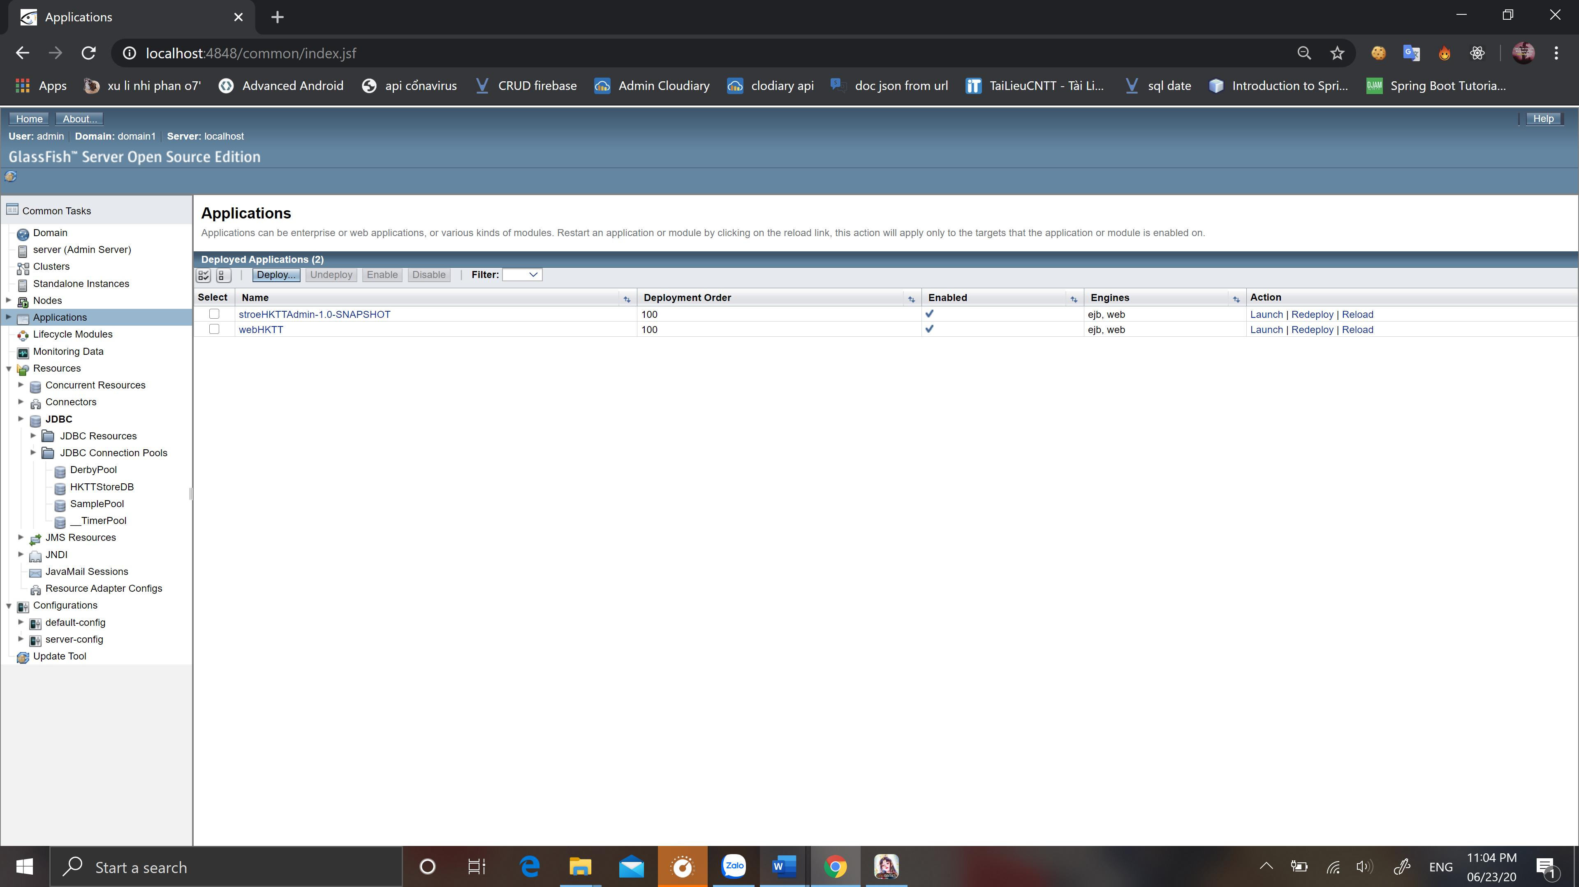

In the next screen, click the "Choose File" button.

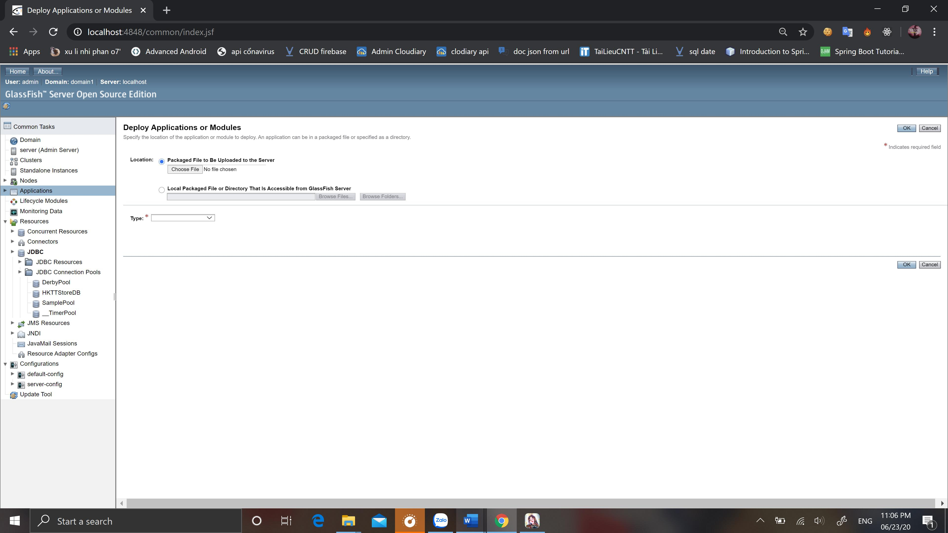

select stroeHKTTAdmin-1.0-SNAPSHOT.war file in Deploy folder and then click "Open"

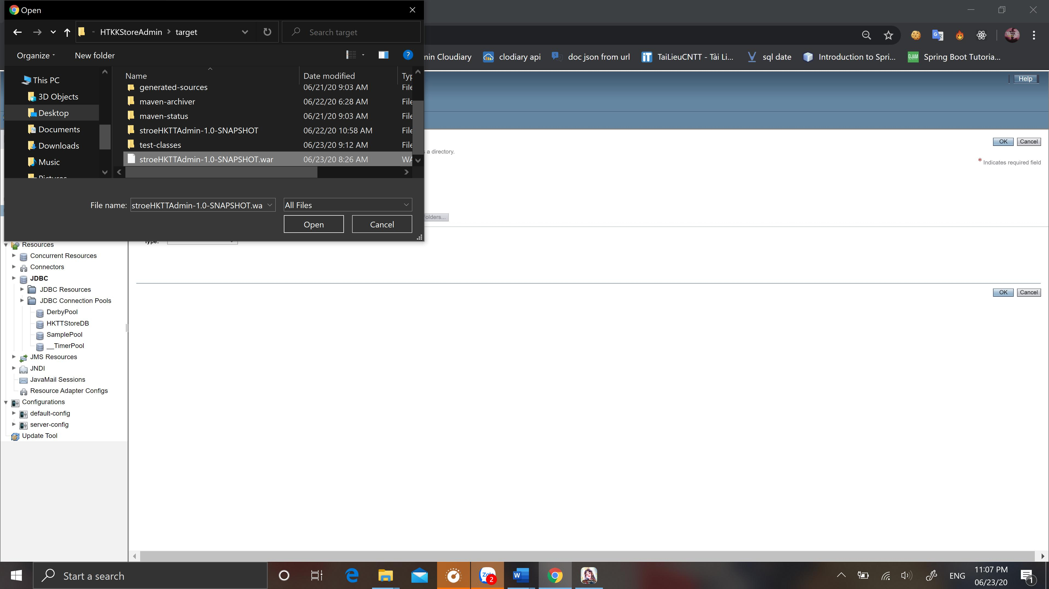

HOLD all the configurations below (Context Root, Application Name ...).

Then press the "OK" button

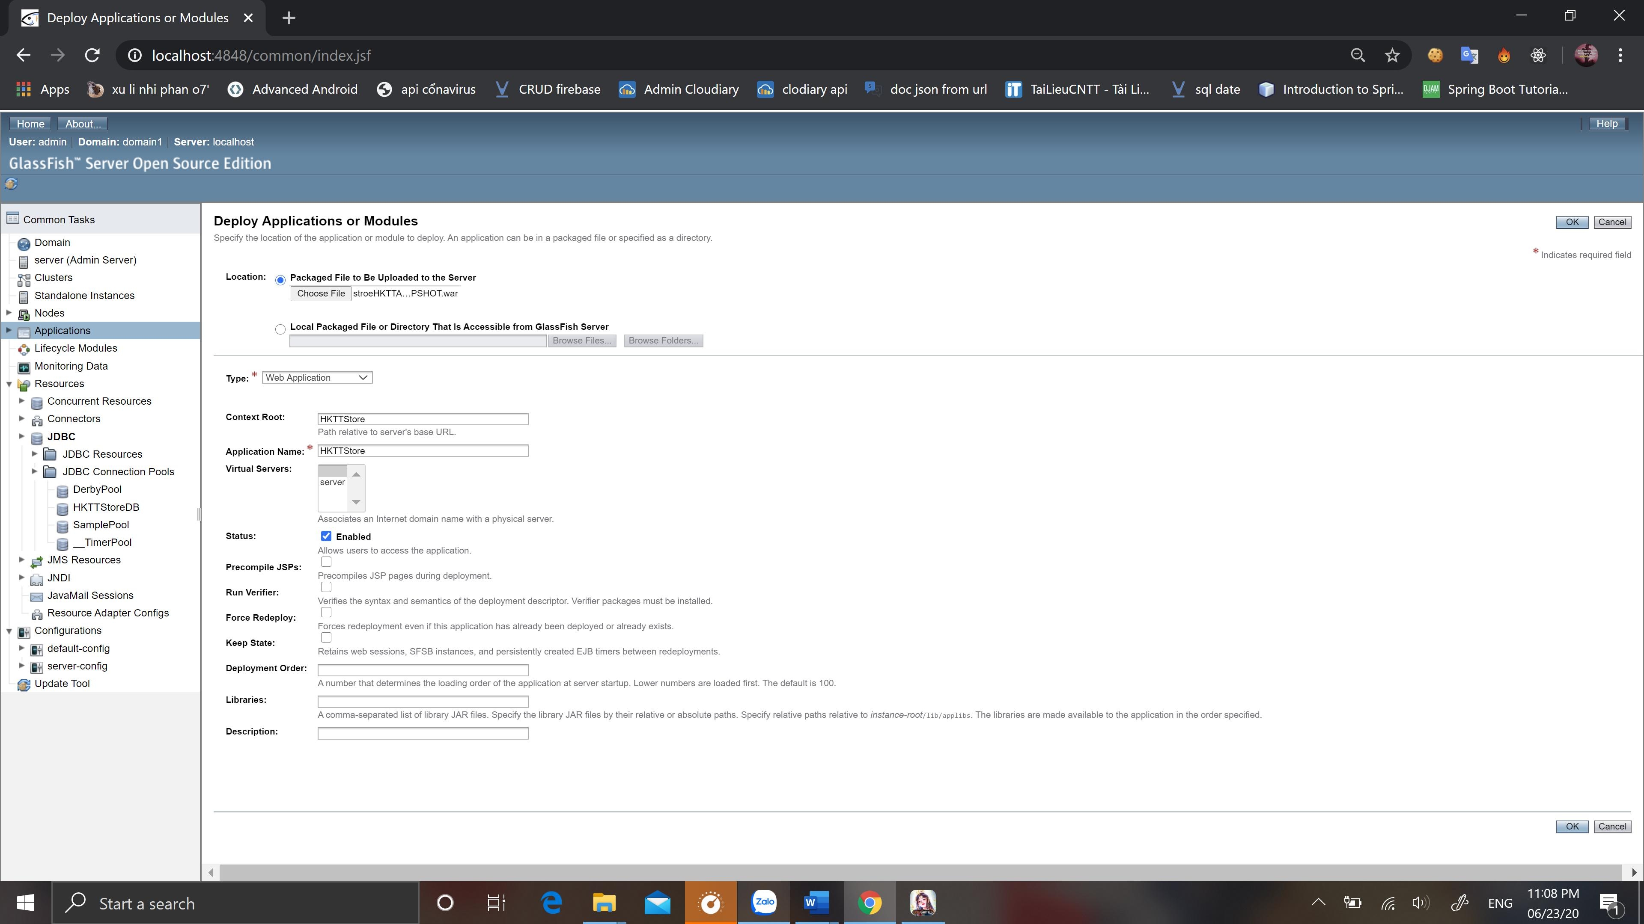

It will take some time for the application to be deployed to the server. During this process should wait until the application is finished deploying. Once the HKTTStore application has been deployed, it will move to the Applications screen.

Click on HKTTStore to switch to the Edit Application window

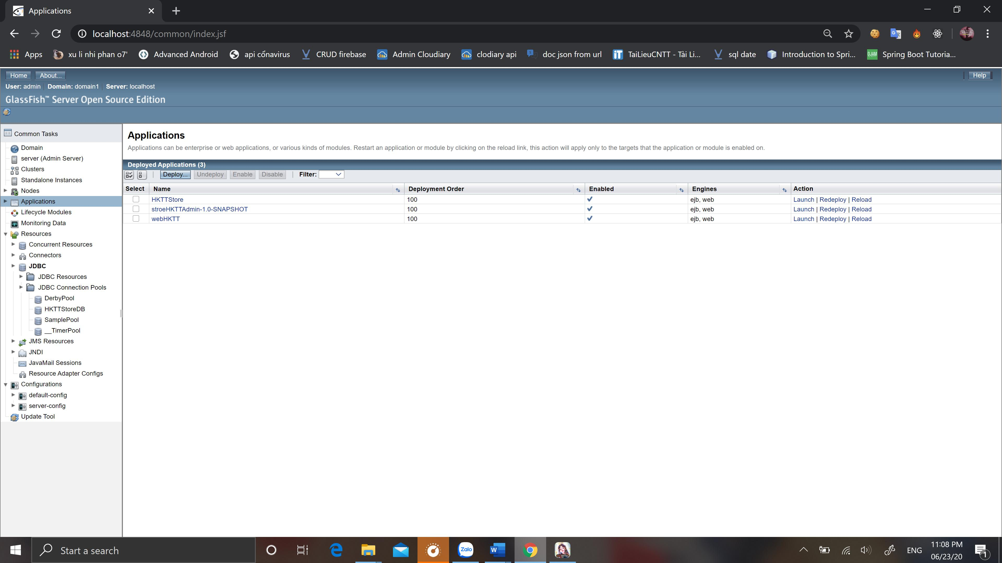

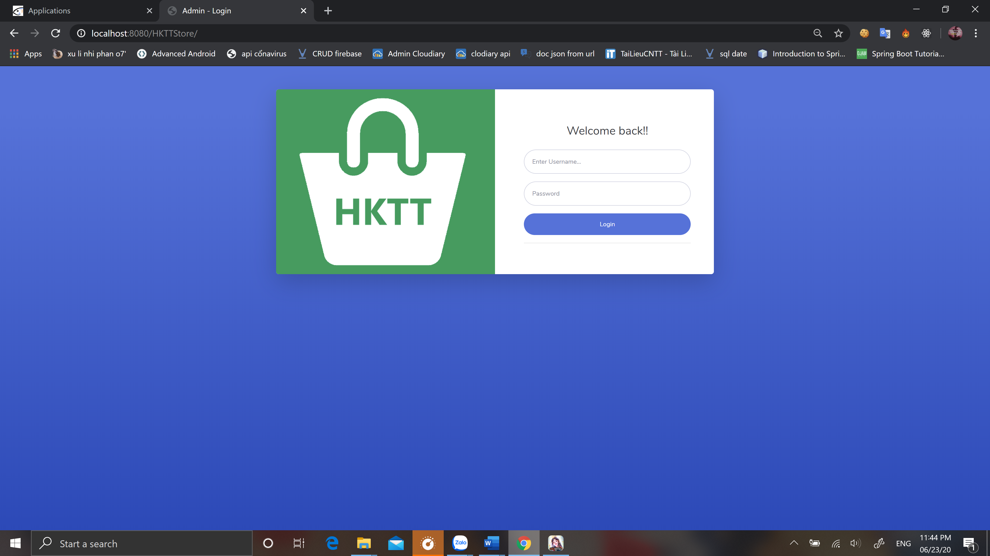

And now, you open a new browser window and enter the following address

[**http://localhost:8080/HKTTStore**/](http://localhost:8080/HKTTStore/)

Login info:

Username: admin

Password: 123456

**Step 4: Setup API:**

Open folder API_Deploy, find file appsettings.json and choose Edit

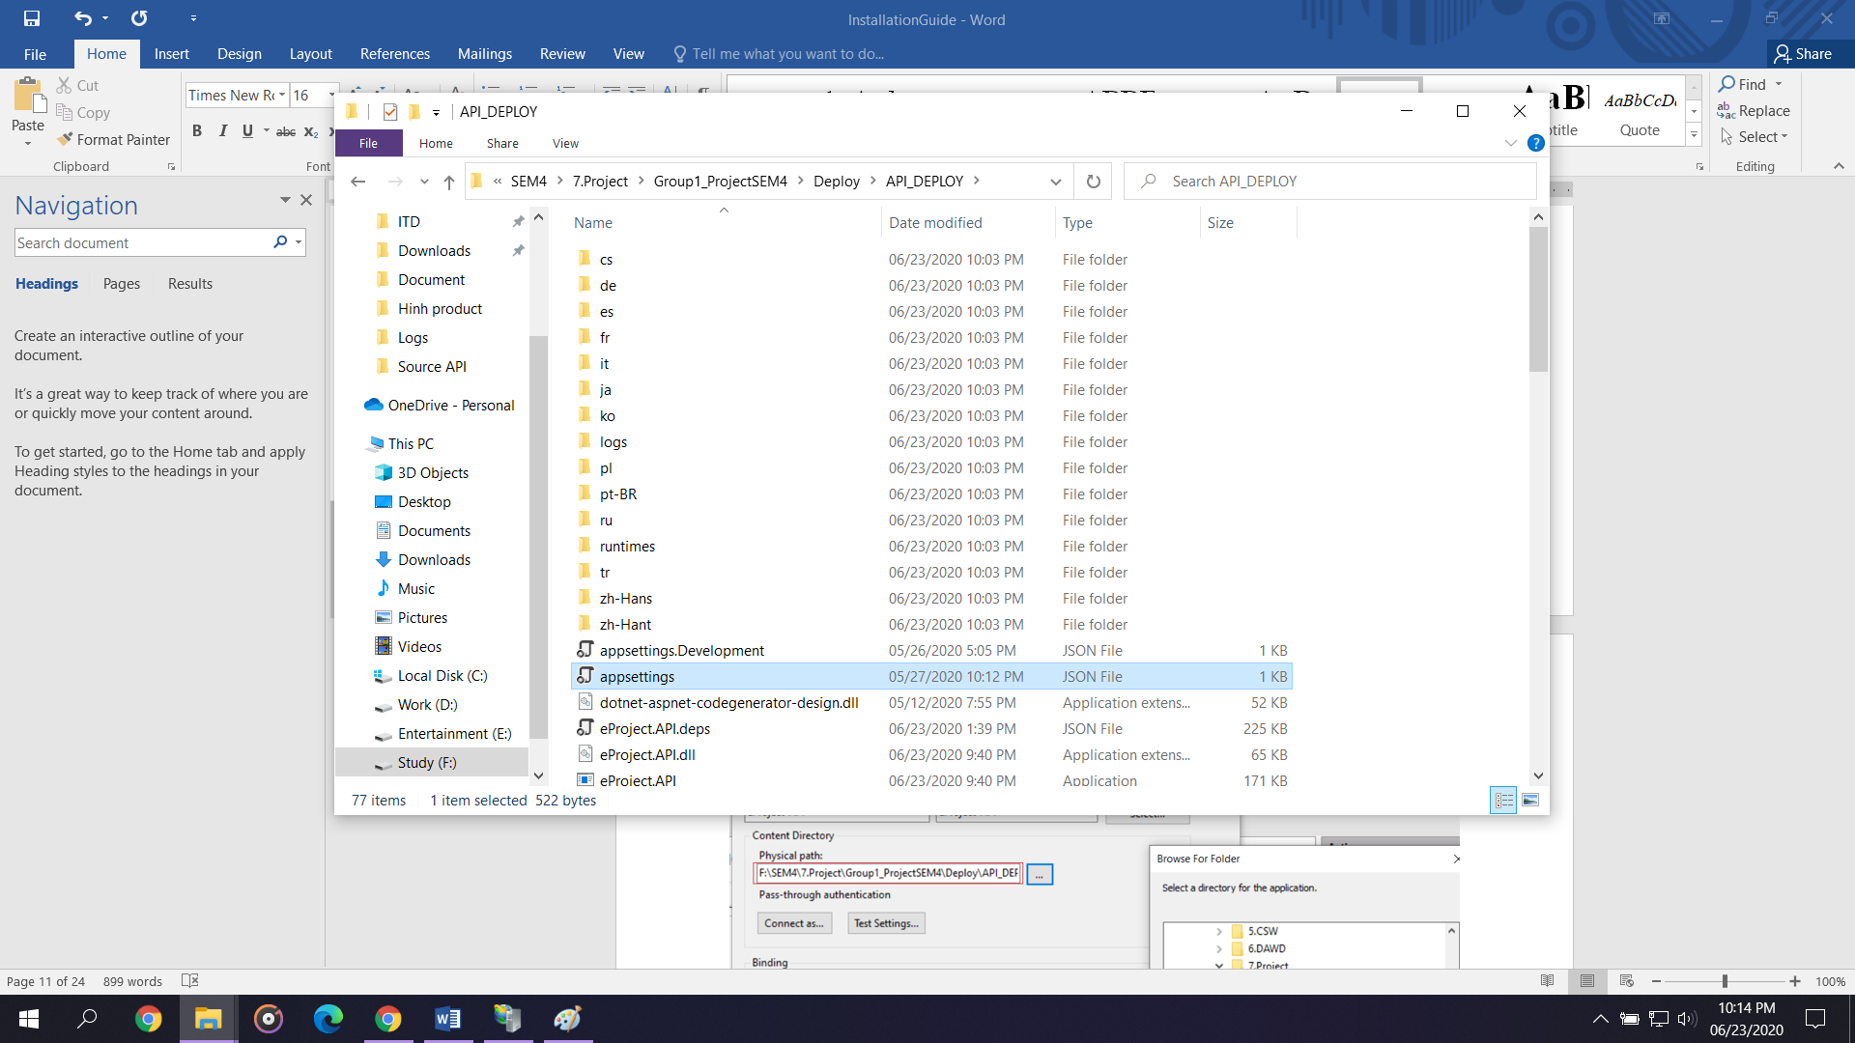

Change information in red box base on your sql server setting

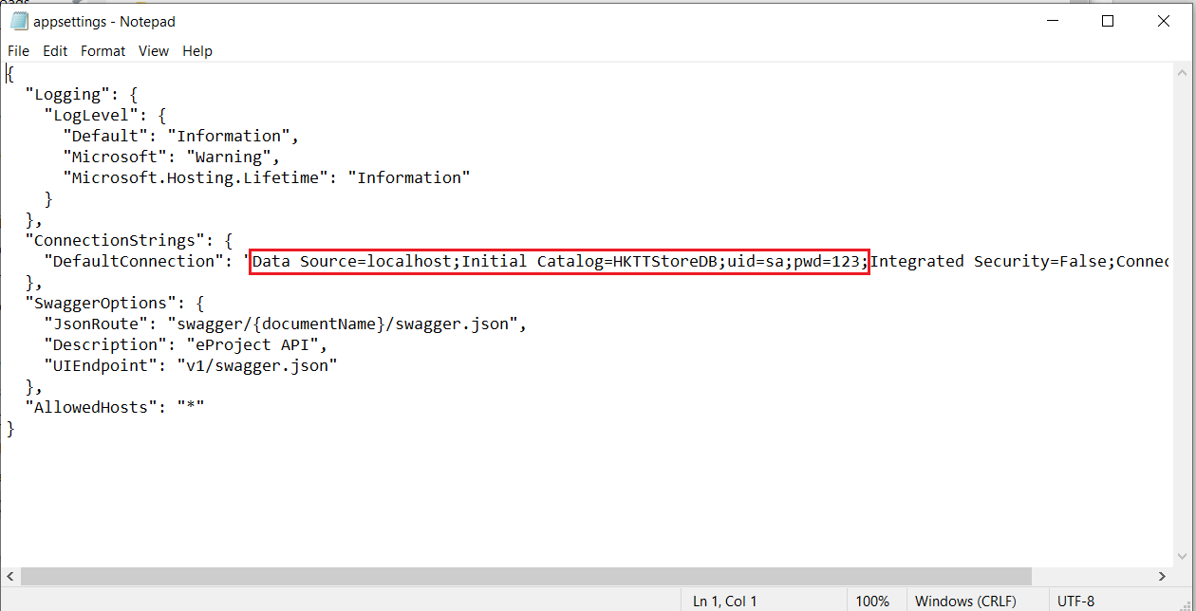

Go to the link: <https://dotnet.microsoft.com/download/dotnet-core/3.1>

And press 2 link in the red box to download. After download finnished, install them.

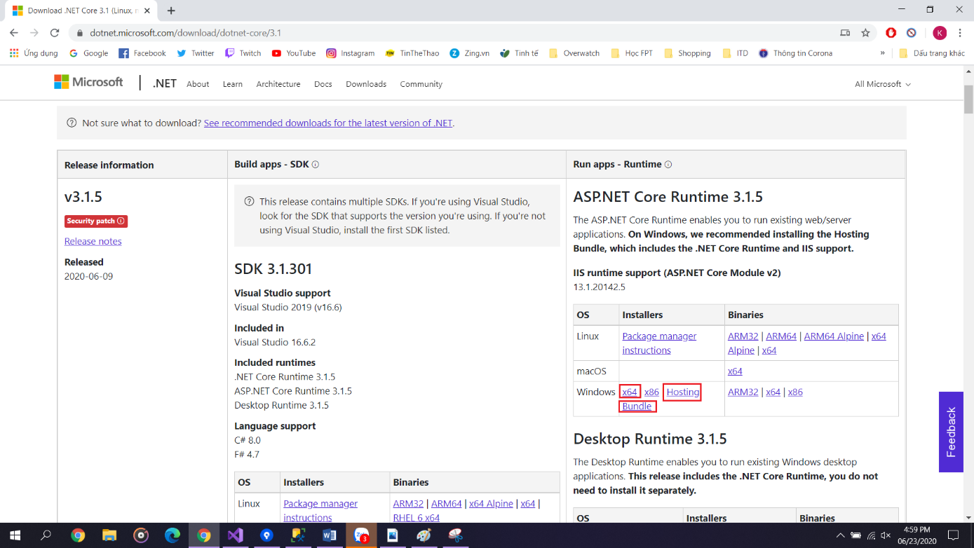

Go to this link to install IIS Manager:

<https://teckangaroo.com/enable-iis-windows-10/>

After install success, open IIS manager.

Right click Sites and choose Add Website

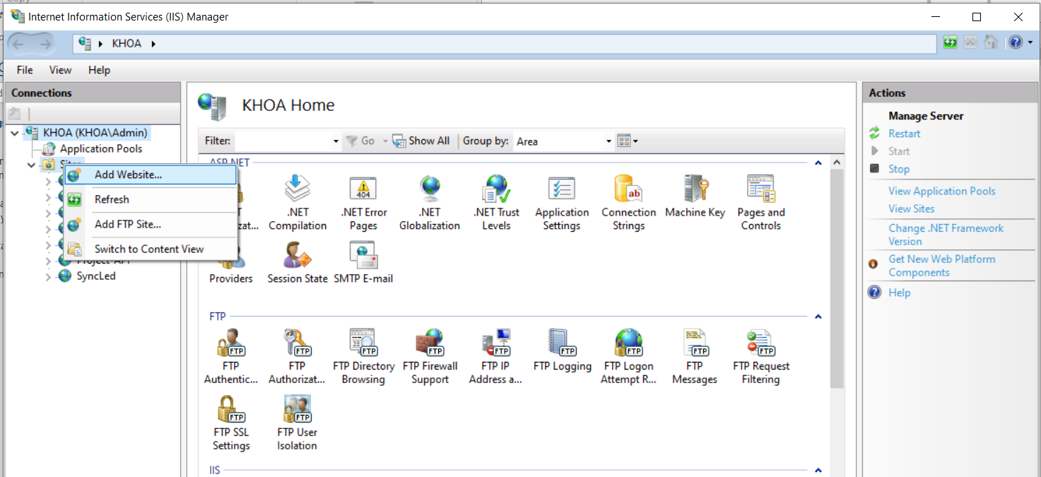

Enter information as example

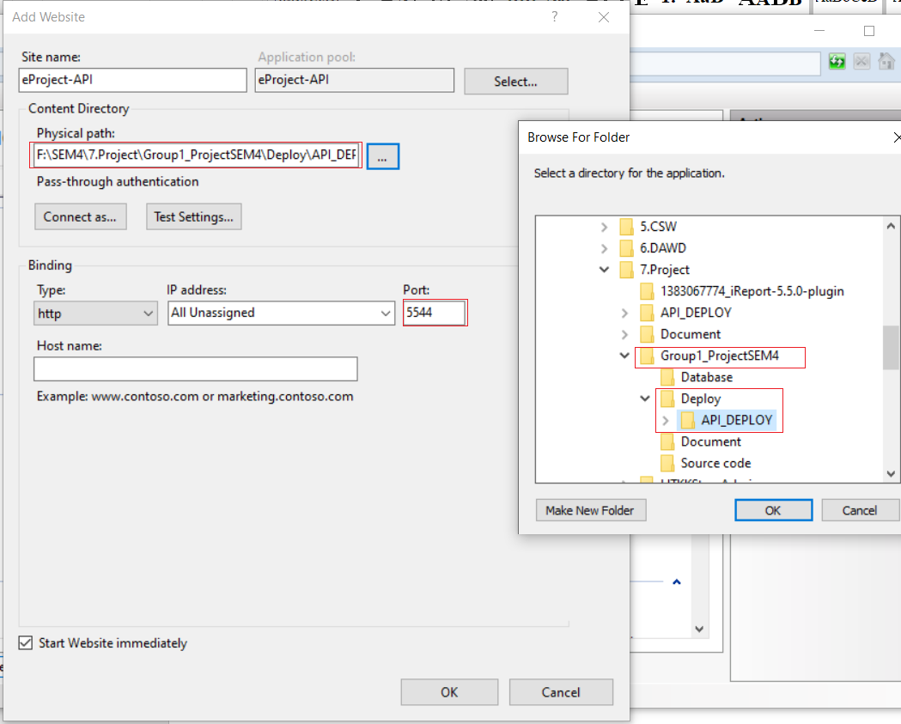

Site name: Can be any name

Physical path: Choose path to folder API_Deploy in Deploy folder of Group1_ProjectSEM4.

Port: Can be any port. Remember this port, we need this port for android.

Press OK.

Righi click on the site we just create and choose Edit permission

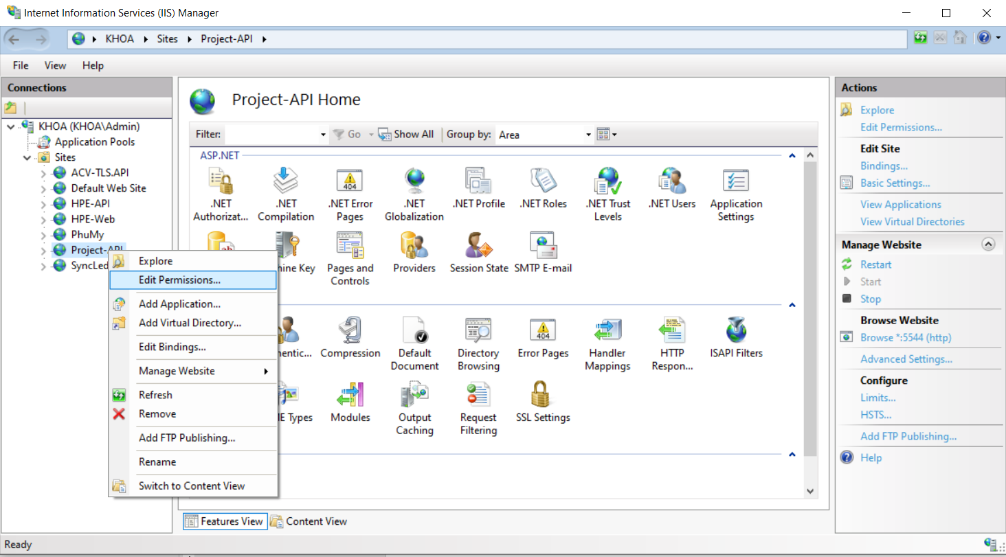

Choose tab Sercurity and press Edit

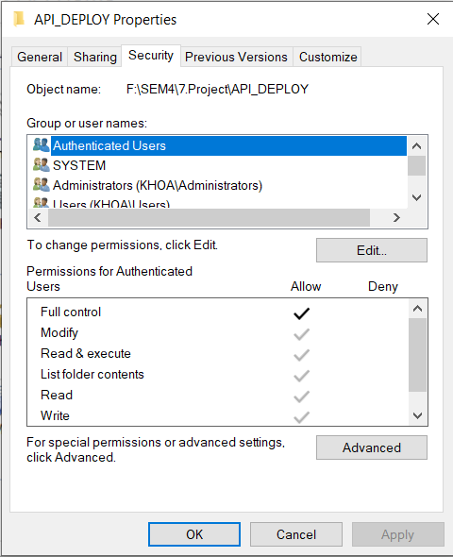

Press Edit -> Add -> Advanced -> Find now

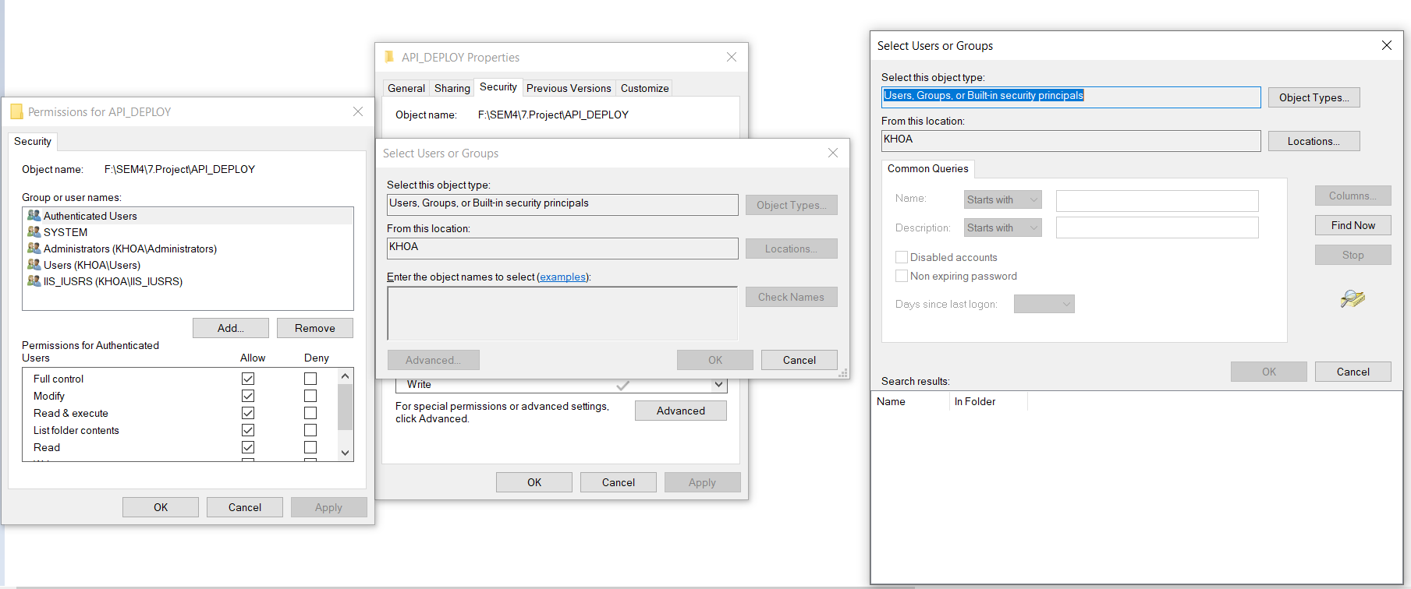

Choose name IIS_IUSERS and click OK -> Click OK

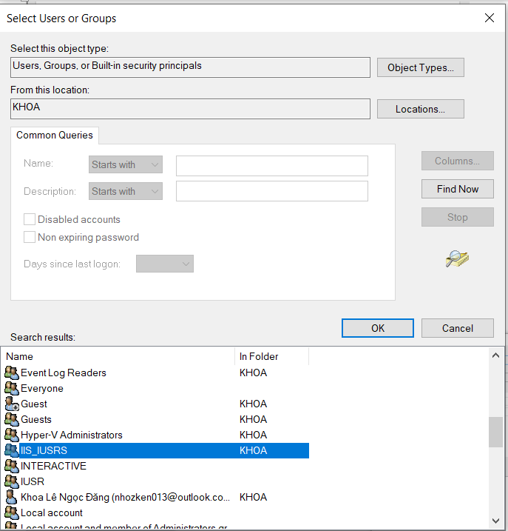

At tab Sercurity, choose IIS_IUERS, Click Edit and choose Allow full control -> Click OK -> Click OK

Click on Browse

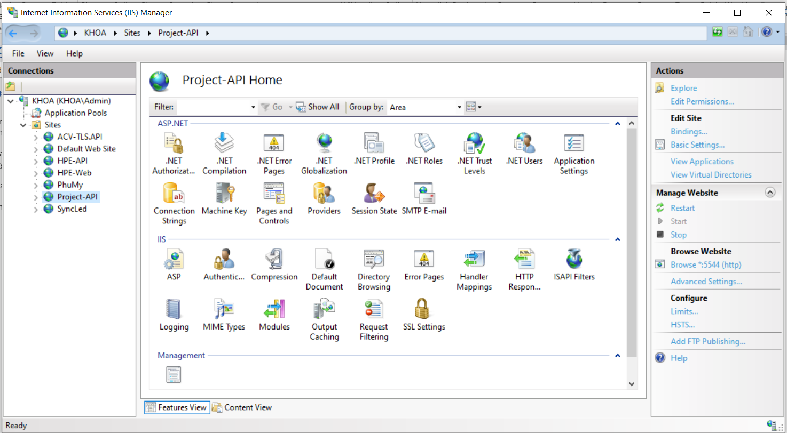

Add swagger/index.html after localhost:5544/

If the web site is loaded like bellow, API is deploy Success.

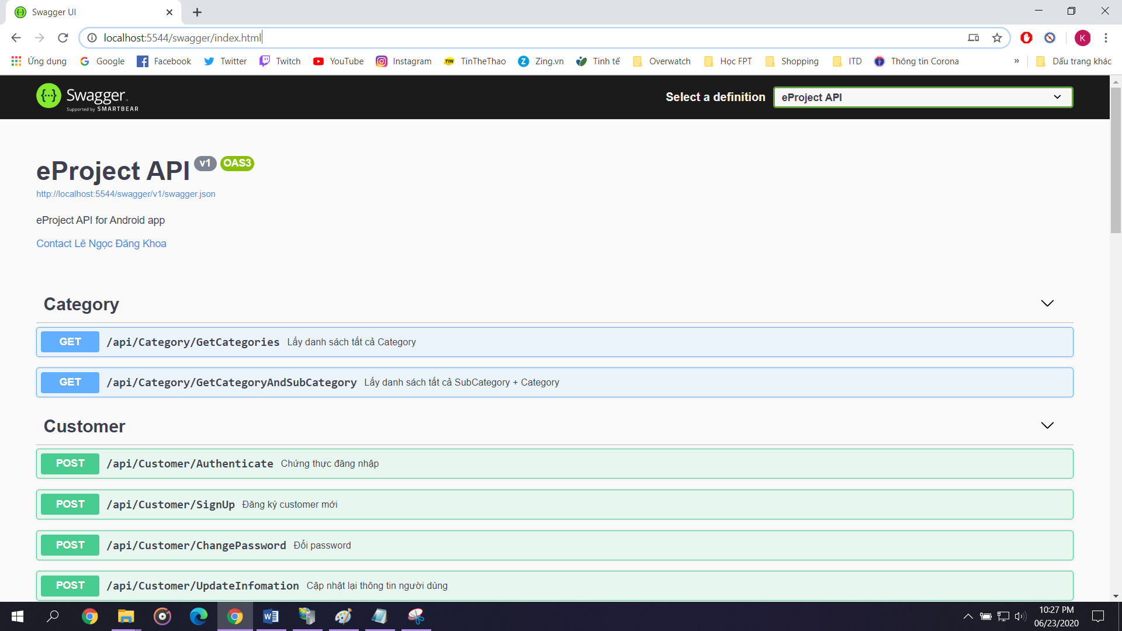

Add rules for port

Open Windows defender Firewall with Advanced Sercurity. Choose Inbound rules and click New rules

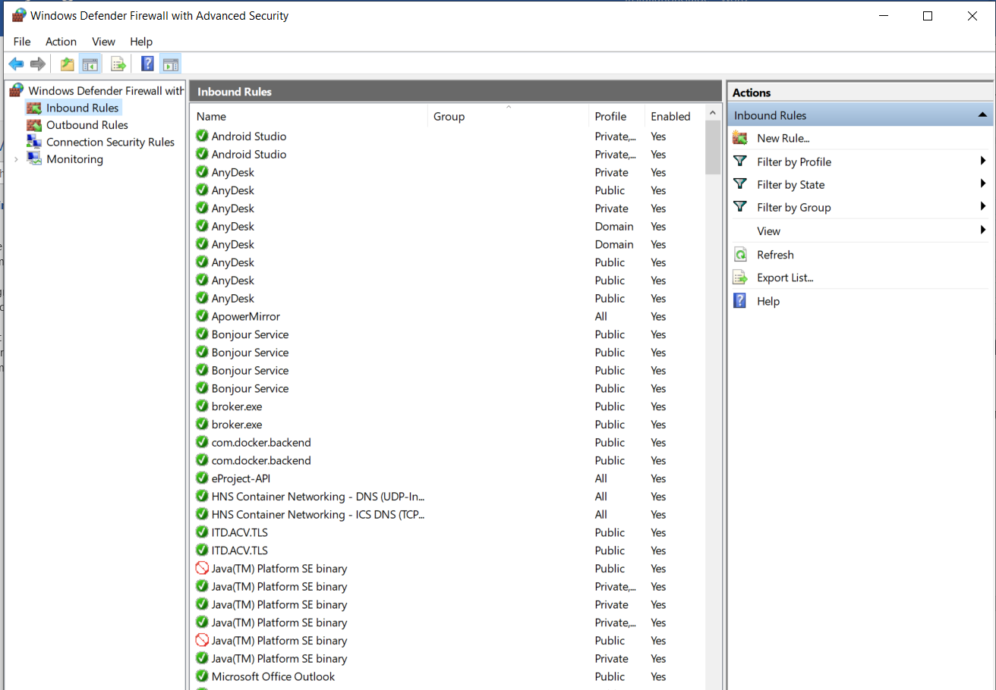

Choose port -> Next

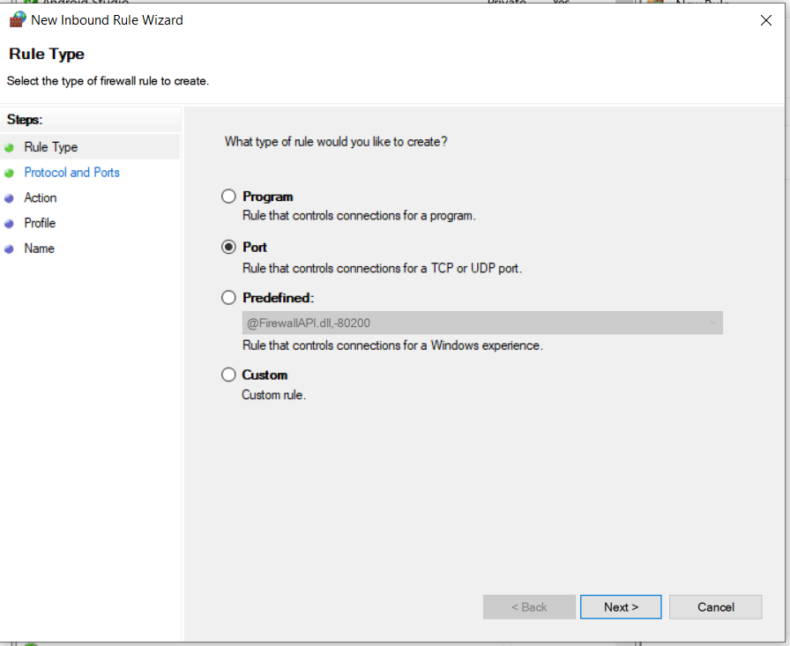

Enter the port you have choose in IIS

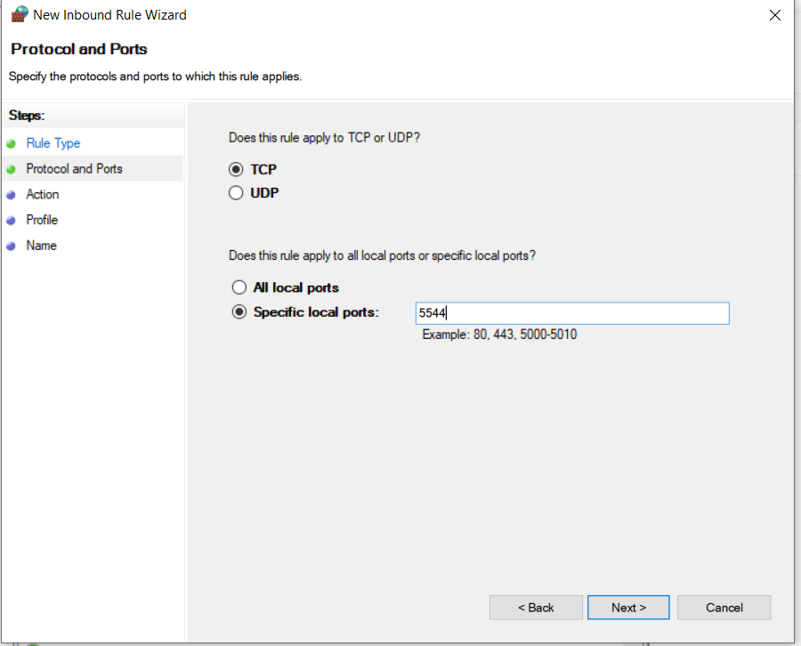

Press Next -> Next -> Enter any name you want and click finnish.

**Step 5: Setup android aplication**

Open cmd and enter ipconfig

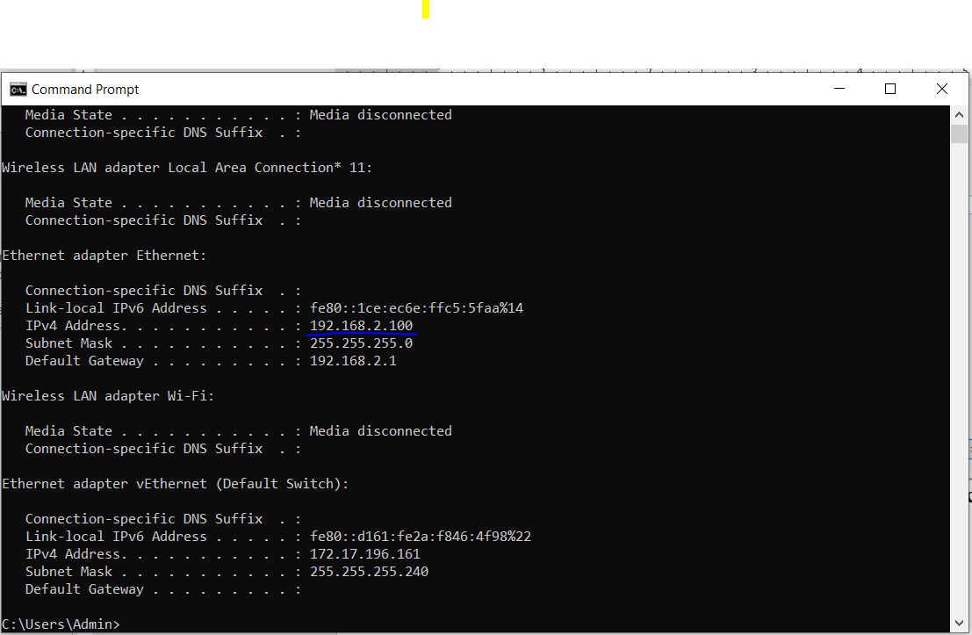

Your IP is 192.168.2.100

Open android souce in source code folder with android studio

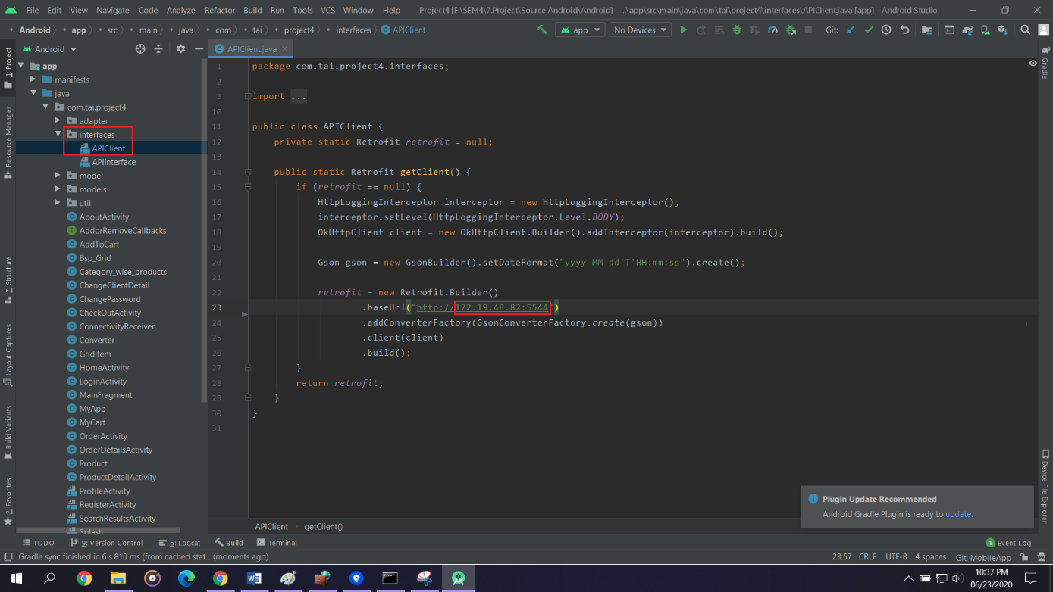

Choose file APIClient in interfaces folder and edit the baseURL = your IP + the port you choose when publish API

Click Run to install app on your phone (your phone need to enable Developer mode).

Since the mobile app depend a lot on the API and we don’t have a publish server to publish our API so we can not generate apk file here.

**Login info:**

You can register a new account or use account:

Email: [lndkhoa95@gmail.com](mailto:lndkhoa95@gmail.com)

Password: 123456